Tom van Vuren TPP
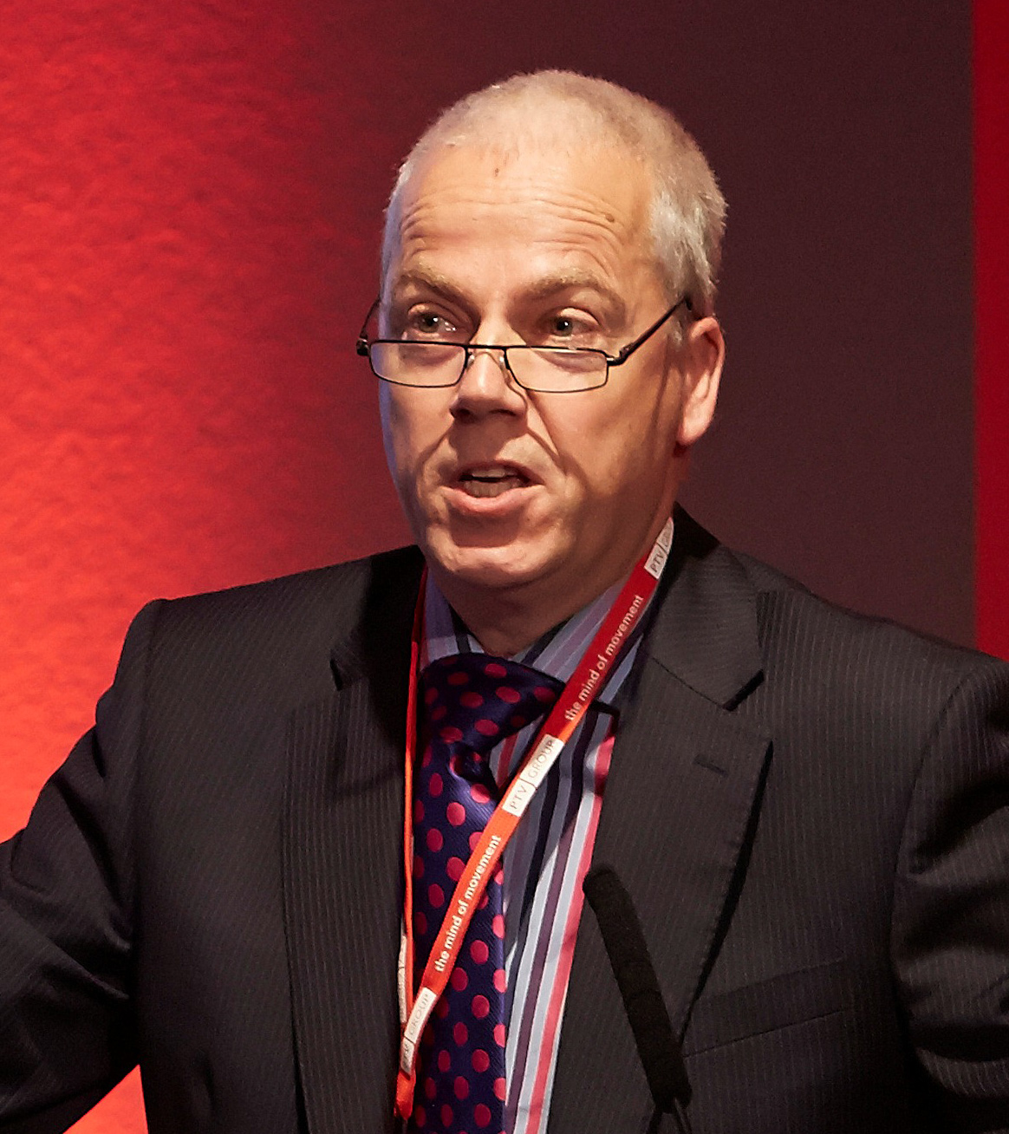Tom van Vuren is one of the UK’s leaders in transport modelling. Although he started his career studying at Delft University in the Netherlands (from where he hails), he came to Leeds to do a PhD and has stayed here. Now working with Mott MacDonald, he has maintained his links with Leeds, where he is a Visiting Professor. Tom has a strong commitment to promoting learning in transport planning. He is a past Chair of the Association for European Transport, the member based organisation that runs the annual European Transport Conference, and for the last 10 years has chaired the Modelling World conferences. He was awarded the TPP in 2009.

Tom relaxes in the country surrounding his cottage near the Malvern Hills.

Tom, what do you with Mott MacDonald?
As a Divisional Director I both direct projects and am one of the management team directing the strategic future of the Division. Mott MacDonald is an employee-owned, 16,000 strong international multidisciplinary engineering and development consultancy. Working in Mott MacDonald means sharing a collaborative culture, and being involved in some amazing projects around the world, working with a very diverse set of colleagues. As a transport planner my job often involves preparing demand forecasts for major transport infrastructure projects – as I like to think, none of these big schemes could get approval or finance without our expertise.

Why is it important for transport planners to work to a professional qualification?
This is really two questions. The first, is why is it important to have a professional qualification? The second is what are the benefits of the process of working towards it?

To start with the first: just like other professions such as engineers or lawyers, it is important that there are standards in what we do, evidence of the quality and integrity of those that are considered professional transport planners, and that a community of peers develops and enforces these standards. A lot of harm can be done by people that believe or are believed to be professionals – for example I am horrified by some of the self-serving but largely unsupported statements made by lobby groups on quite fundamental transport planning issues, without referencing the body of evidence that is available to bring balance and rigour to the debate. Everybody has an opinion on transport issues and often the weight of that opinion in the debate does not seem to be tempered by a lack of qualifications. Over time I expect that the transport planning profession will get a stronger voice, and one that will be recognised.

Before being qualified, the journey towards it should be rewarding. It will expose you to most if not all of the aspects of transport planning, ensuring you will be more rounded in your career, and also helping you identify what in the quite broad professional area of transport planning you really enjoy doing.

What do you sees as the main benefits of the TPS Professional Development Scheme?
For me, the PDS is a framework within which both the graduate and the employer sign up to a joint objective: training up to a professional standard. As an employer it gives us a commitment from our staff to Continuous Professional Development. Until about ten years ago such structured CPD was hard to define and even harder to implement. And, as in transport planning our staff resources are our main asset, training and development are critical to releasing value from our employees. As a graduate, the PDS ensures that your employee is signed up to the development of your career, and that the training you receive is relevant, comparable between employers and hence valuable. It is a win-win situation.

One of the greatest benefits (and, admittedly, challenges) is that the PDS requires those that are enrolled to rotate between teams that focus, certainly in larger organisations like Mott MacDonald, on specific aspects of the wider transport planning profession. So, rather than being pigeon-holed as (heaven forbid!) a transport modeller early in your career, the PDS will ensure that you will experience travel demand management, development planning, transport strategy work as well. It makes you more rounded and again, that’s a good thing for you as well as your employer.

What advice would you give a young transport planning just starting to develop their career?
Wow. That’s a tricky one. Every transport planner’s career will be different. That’s the beauty of what we do and I would not want to change that. There are so many reasons why people choose transport planning as a profession; so many different roles; so many different organisations to work in.

But the first piece of universal advice would be to grab every opportunity to learn. Work with the best, with people that inspire you, challenge and be challenged and absorb the best of their behaviours into your own.

Second: share your time, your knowledge, your contacts freely. We are a collaborative profession. We also work in a political environment. Rarely is there a single solution, almost always there are winners and losers. Even if you are passionate about a particular issue, a particular mode, a particular project, be open-minded to all the arguments for and against. And instill that behaviour in your colleagues. The way to do it is to read widely, in professional journals and on-line. The available material is staggering! And engage in the profession – TPS, CIHT, CILT all organise many events on topical subjects that will broaden your views, deepen your knowledge and enable you to build wide professional networks.

When has TPP benefited you?
Given that I achieved TPP through the senior route, after almost 25 years in the profession, the TPP title has not directly benefited me. The benefits to me have been more through my colleagues that are currently pursuing the PDS or have gained the TPP. They are more useful resources in my projects than they otherwise would have been. The qualification is rigorous but allows the diversity of our profession and of the candidates to shine through. And I know, if someone with a TPP qualification applies for a job with me, that they will be excellent.

How does Mott MacDonald recognise TPP in career development?
Within Mott MacDonald, much of our training and development focus is still on the traditional Chartered Engineer qualification; and not surprising because it is a solid accreditation route and relevant for the majority of our graduates. However, it was a major achievement when, a few years back, the company accepted the PDS and the TPP qualification as equal to Chartership in engineering.

For us the route towards TPP is as important as the qualification itself. First, because not everyone embarking on the PDS may complete it, or stay with us for the duration. The structured CPD it offers has value in its own right. Second, because the time to achieve TPP (in my experience 7 years or more) is longer than the average engineer will take to achieve a Chartered status, so that we tend to promote our transport planning staff to the Chartered equivalent level before they acquire the TPP accreditation. Then the achievement of TPP is more of a personal achievement, rather than a benefit to business and a route to direct status or salary increases, which I think is actually correct.

Should you apply?
Unequivocally yes. I am a TPP Reviewer and bar one, all candidates that I have interviewed aspired to TPP not because they expected financial gain or increased status, but because they were proud of their profession, their personal achievements and wanted to be recognised as professionals. There are still only a few hundred TPPs in the country; there must be hundreds of thousands Chartered Engineers, Chartered Surveyors and Chartered Planners. We need a larger volume of Transport Planning Professionals before we will see an attitude change towards the qualification as a prerequisite for senior roles, such as Project Directors and Expert Witnesses. But we are on the right path – I understand that both Transport Scotland and the Welsh Government are beginning to stipulate the TPP qualification for key people working on their projects.

We as employers have a responsibility too and in Mott MacDonald we take that very seriously.

